OLSAT Monitoring System

# Foreword

OLSAT Monitoring System is a software that you can use to ease out the tedious tasks required by manual OLSAT result computing. You can also manage and monitor the results of the students and export the results in a report.

You will be given access to the OLSAT Monitoring System by the Xavier School ITS Department.

Please be reminded that the OLSAT Monitoring System is currently in development, and this document shall be updated with the features that are scheduled to deploy.

We would love to hear about your suggestions. If there is any improvement that you would like to get implemented, please contact us at Nirio@i.xs.edu.ph

OLSAT Monitoring System

# User Hierarchy

User Hierarchy is a feature of the OLSAT Monitoring System. It is designed so that the operators of the System, which we would call Admins, can be grouped into their level of accessibility in the system. Currently, there are two levels of accessibility, Super Admin and Admin. Super Admin has full access to the system, while Admin is only limited to viewing results.

OLSAT Monitoring System

# Table of Contents

Registration

Login

# Registration

The Registration page is where the operations would start. One must Register first to gain access to the system. Please keep in mind that this procedure is only available once. The account that would be registered through this method would be granted a Super Admin status.   
  
Please fill out the fields, and click on the Register button, or simply click on Enter key using the keyboard.

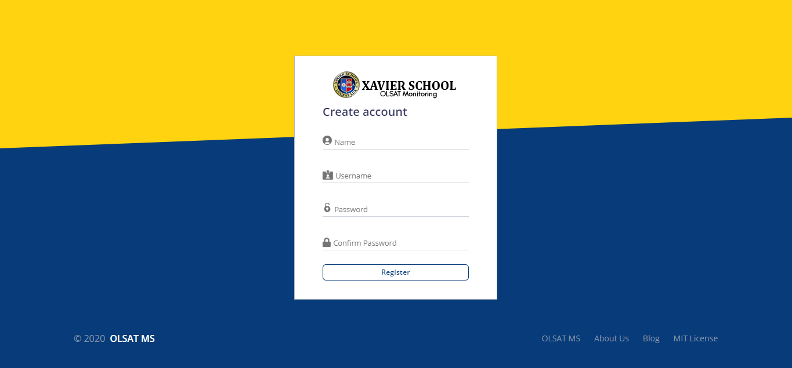

# Login

After signing up through the Registration page, you will then be redirected to the Login Screen.  
  
Please fill out the form using the Username and password that you have entered on the registration page.

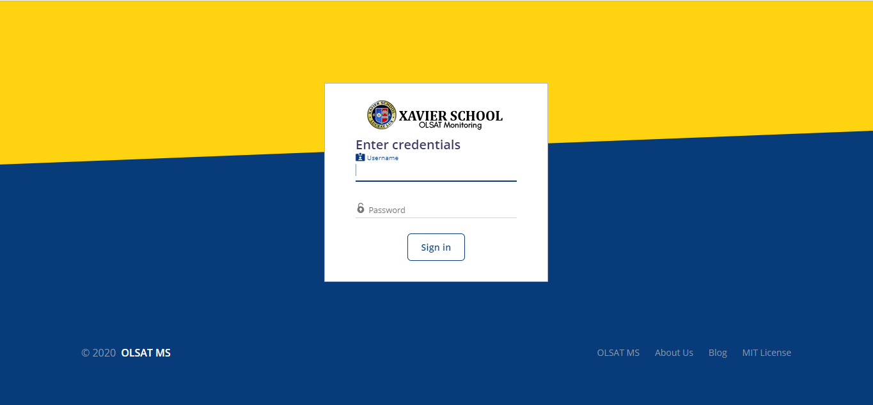

# User Interface

We grouped the Image below by color to give you an explanation for the user interface.

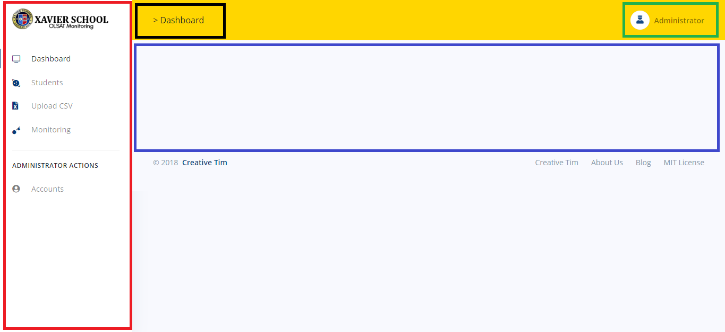

Red – This is called the Sidebar. This is where you will be navigating to the different parts of the System. We would now then refer to the term “Section” as the location where a part of the system can be located through the Sidebar.

Black – This is called the Breadcrumb. This is to help in navigating in each subsection of every section, so that you can be quick in navigating between subsections. Currently, this is still in Development, but this would be finished in due time.

Green – This is the Administrator Profile. Currently, the Log out button of the system can be found here by clicking on it.

Blue – This is called the Content Screen. The contents of every section and subsection shall be displayed here.

# Dashboard

After logging in to the system, you will be brought to the Dashboard Section. This section is currently under construction, but this will be the section that the summarization of Data in the System will be placed.

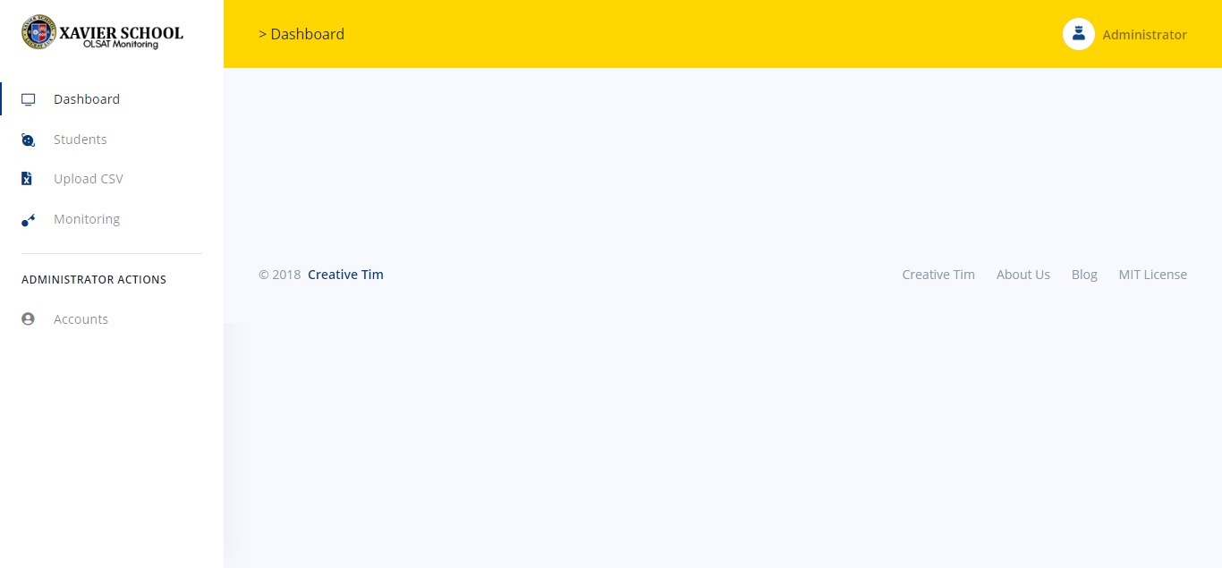

# Students

By navigating to the Students Section, you will then be brought here. You will see on the content sub section, a search bar, a sorting tool, and the search results. (di pa nasasama yung pagination, iuupdate pa yung page)

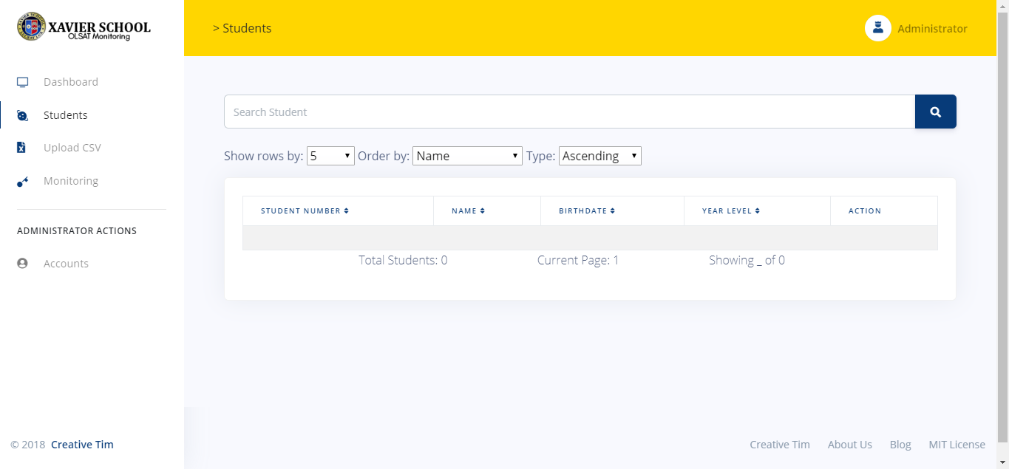

# Upload CSV

By navigating to the Upload CSV Section, you will then be brought here. You will see on the content sub section, two “Cards” that designate which CSV you would then choose to operate on.

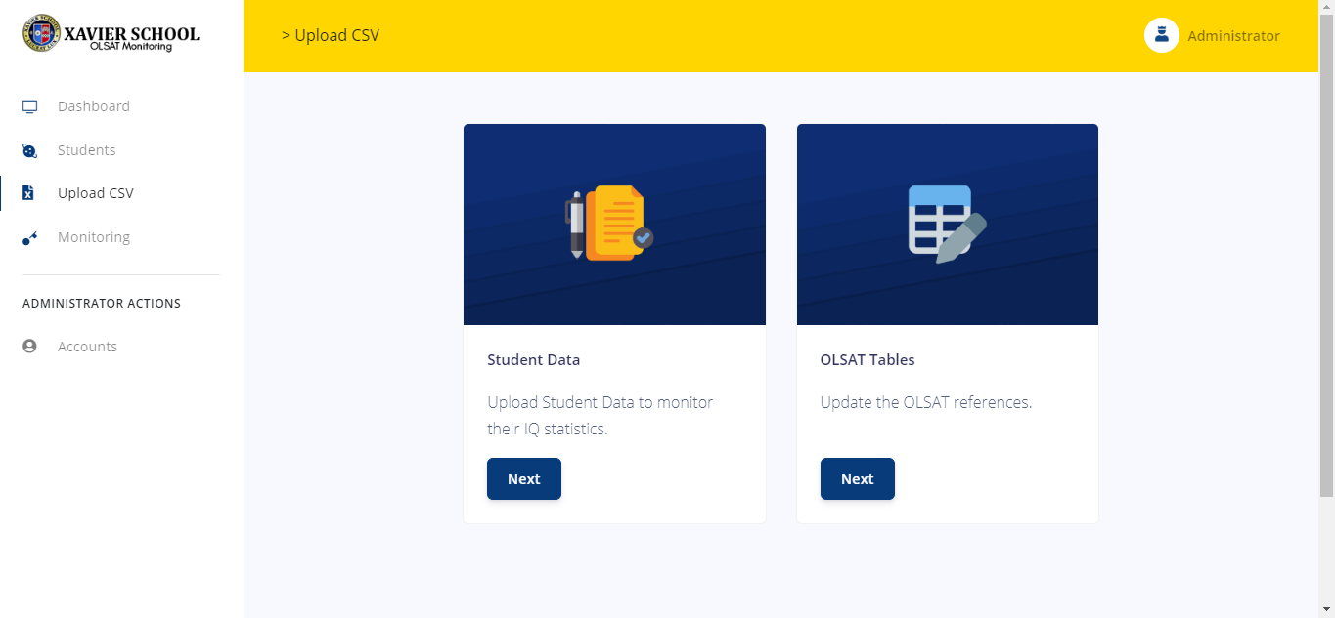

# Monitoring

By navigating to the Monitoring Section, you will then be brought here. You will see on the content sub section, an interface that looks like from the one in the Students Section. Here, we added tabs, to group the results according to an area of the psychometric result. (aayusin pagtapos maayos yung sa uploading ng student)

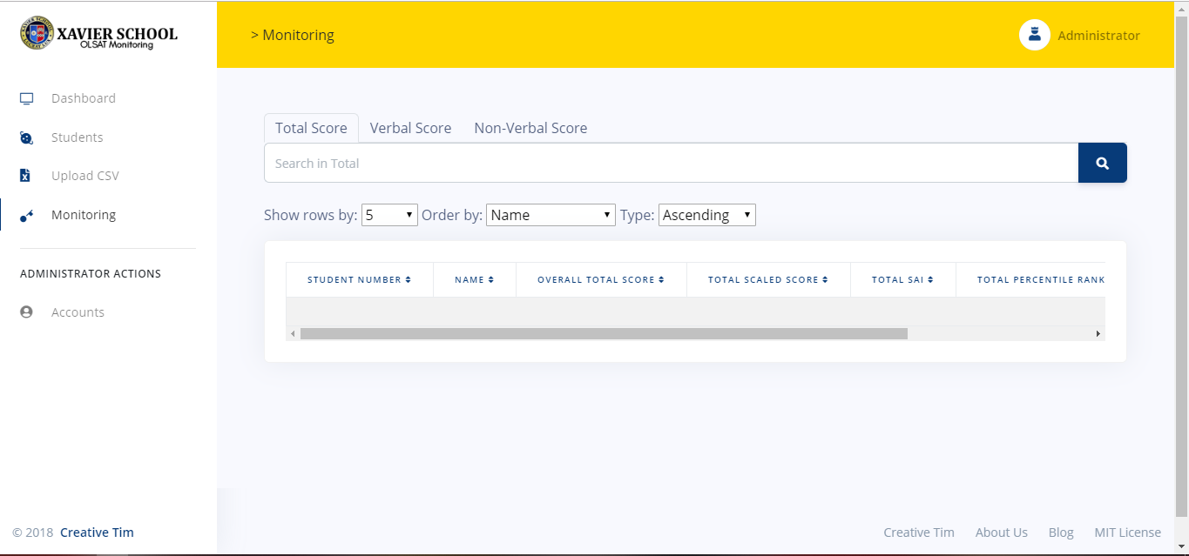

## Naming a SET

A set can be named in several ways. The first way of naming a set is using the curly brace notation { } wherein the elements are written within it.

### Using Elements to Describe a Set (Roster Form)

For example {1, 2, 3, 4, 5, 7} is a set while {2, 4, 6, 8, 10} is another set. This means that the elements stated in the notation are the only members of that set and nothing more. Anything that is not stated on that set cannot be assumed to be the member of that set.

### Describing the Elements to Describe the Set (Set Builder)

However, if a set contains elements that are too many to mention, a descriptive notation can be helpful. For example, if you want to show a set which contains all positive whole numbers, you can write {1, 2, 3, 4, 5, 6 … so on and so forth. But this won’t be enough to concretely describe the set that you want to convey. Instead, you can write {N : N is a whole number} instead of writing its member elements. This way, all possible elements of that set are encompassed. *The notation {N : N is a whole number}* is read *as the elements N such that N is a whole number*. In this chapter we will dwell and practice more on using this notations.

## The EMPTY SET

The empty set, or null set, is a set containing no objects. It is written as a pair of curly braces without eny element inside { } or by using the symbol null ∅.

This set will come in handy in answering questions which excludes all other possibilities in a given set. This can also be used to describe impossibilities and other contradictions for a given set.